1. **Create five new databases - Student, Employee, Bank, Library, Family**

CREATE DATABASE STUDENT;

CREATE DATABASE EMPLOYEE;

CREATE DATABASE BANK;

CREATE DATABASE LIBRARY;

CREATE DATABASE FAMILY;

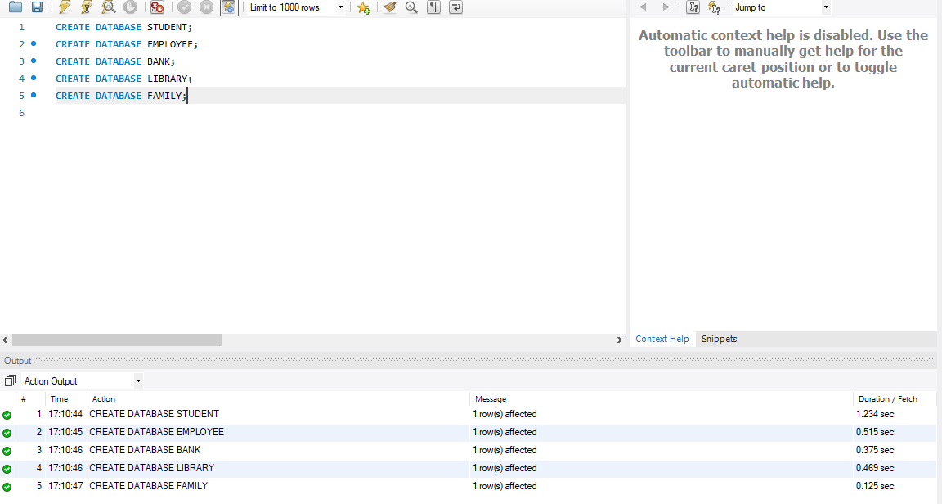

**2. Create five separate Tables namely studentdetails, employeedetails, bankinfo, bookdetails and familytree with five different fields respectively**

USE STUDENT;

CREATE TABLE STUDENTDETAILS(REGNO INTEGER, NAME VARCHAR(25),DOB DATE,DEPT VARCHAR(3),LOCATION VARCHAR(20));

DESC STUDENTDETAILS;

USE EMPLOYEE;

CREATE TABLE EMPLOYEEDETAILS(EMPNO INTEGER, NAME VARCHAR(25),DOB DATE,DEPT VARCHAR(3),LOCATION VARCHAR(20));

DESC EMPLOYEEDETAILS;

USE BANK;

CREATE TABLE BANKINFO(ACNO INTEGER, NAME VARCHAR(25),DOB DATE,AGE INTEGER,BRANCH VARCHAR(20));

DESC BANKINFO;

USE LIBRARY;

CREATE TABLE BOOKDETAILS(BOOKNO INTEGER, NAME VARCHAR(25),AUTHOR VARCHAR(25),AMOUNT INTEGER,STOCK INTEGER);

DESC BOOKDETAILS;

USE FAMILY;

CREATE TABLE FAMILYTREE(NAME VARCHAR(25),DOB DATE,AGE INTEGER,GENDER VARCHAR(3),LOCATION VARCHAR(20));

DESC FAMILYTREE;

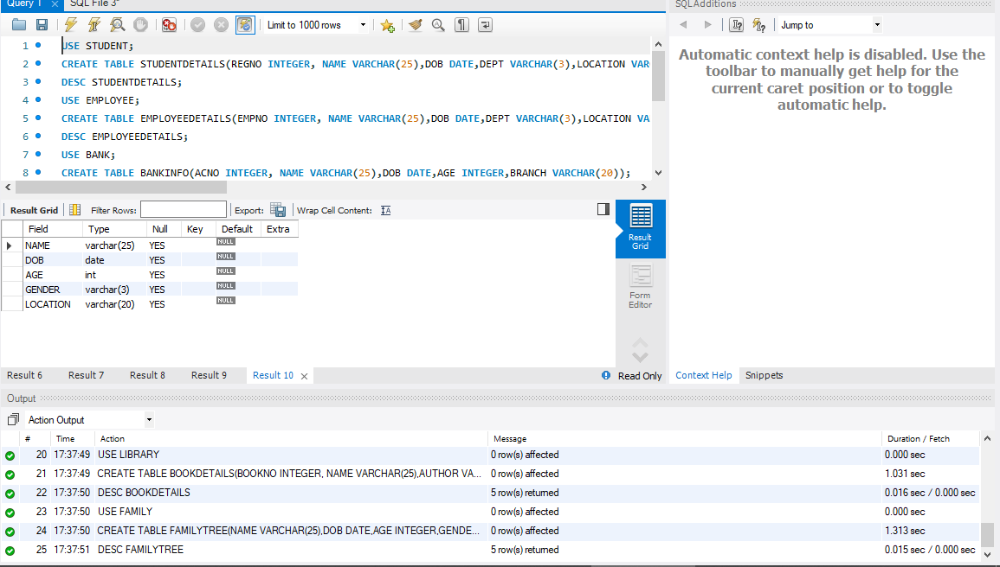

1. **Use Display and insert queries and display your output**

USE Student;

INSERT INTO studentdetails values (1,&quot;abilash&quot;,12,&quot;CHENNAI&quot;,12000);

INSERT INTO studentdetails values (2,&quot;bruno&quot;,12,&quot;COIMBATORE&quot;,13000);

SELECT * FROM studentdetails;

USE Employee;

INSERT INTO employeedetails values (1,&quot;akash&quot;,32,&quot;CHENNAI&quot;,120000);

INSERT INTO employeedetails values (2,&quot;ebinesh&quot;,33,&quot;CHENNAI&quot;,133300);

SELECT * FROM employeedetails;

USE Bank;

INSERT INTO bankinfo values (2,&quot;ebinesh&quot;,33,&quot;CHENNAI&quot;,13300);

INSERT INTO bankinfo values (4,&quot;santhosh&quot;,33,&quot;CBE&quot;,423535);

SELECT * FROM bankinfo;

USE Library;

INSERT INTO bookdetails values (2,&quot;GREAT BOOK&quot;,330,&quot;HANUMAN&quot;,200);

INSERT INTO bookdetails values (3,&quot;GOOD BOOK&quot;,310,&quot;RAMAN&quot;,250);

SELECT * FROM bookdetails;

USE Family;

INSERT INTO familytree values (3,&quot;SATHOSH&quot;,30,&quot;cbe&quot;,&quot;M&quot;);

INSERT INTO familytree values (4,&quot;venkat&quot;,32,&quot;bombay&quot;,&quot;M&quot;);

SELECT * FROM familytree;

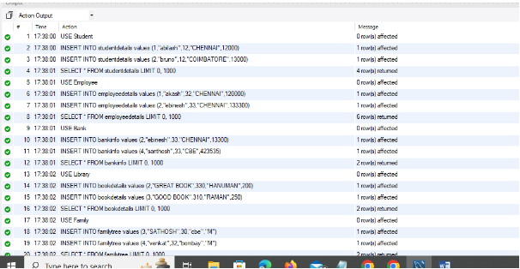

Studentdetails:

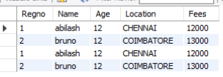

Employeedetails:

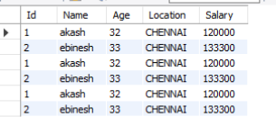

Bankinfo:

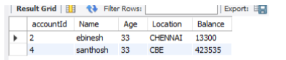

Bookdetails:

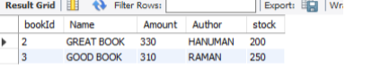

Familytree:

